LOCATION : NATIONWIDE
DATE : 17.03.2017 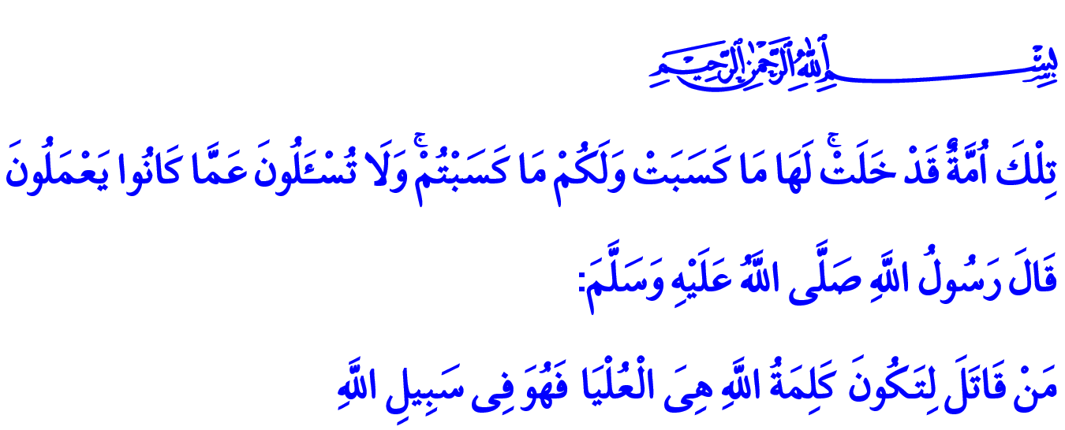
ÇANAKKALE: WHERE MARTYRS MADE HISTORY
Honorable Believers!
In the verse I have recited, the Almighty enjoins: “Those are a people who have passed away. Theirs is that which they earned, and yours is that which you earn. And you will not be asked of what they used to do.”
Brothers and Sisters!
In this verse, the Almighty Lord calls on us to learn from the past in building our future. Because what happened in history is not mere memory. History is our present and future as much as it is our past. History is our values that shed light on our future. There are major incidents and victories in history which must be passed on from generation to generation and never be forgotten. One of the greatest ones in our nation’s history is the one at Çanakkale.
Honorable Brothers and Sisters!
Çanakkale is the place where financial might fell to its knees against faith. Çanakkale is the place where our Lord’s good tidings were manifested once again in which he says: وَلَا تَهِنُوا وَلَا تَحْزَنُوا وَاَنْتُمُ الْاَعْلَوْنَ اِنْ كُنْتُمْ مُؤْمِن۪ينَ “Do not weaken and do not grieve. You will be superior if you are believers.” Çanakkale is where faith clinched its victory over disbelieving, truth over falsity, the right over the wrong. Çanakkale is where so many sons of this homeland from north to south, from east to west ran to martyrdom shoulder to shoulder for the holy cause. Çanakkale is where martyrdom became epic and a nation arose with Allah’s love as described by our late Independence Poet Akif:
How mighty you are that your blood saves oneness,
Only the lions of Badr were as glorious as you.

Honorable Believers!
Çanakkale is an exceptional school that taught the contemporary world the ethics and law of war. Our nation taught an unforgettable lesson of humanity against shameless attacks at its very existence. Our little Mehmets who ran to the front with “Allah Allah” cries demonstrated a great spirit by carrying wounded enemy soldiers on their backs and giving them water from their own waterskins.
Brothers and Sisters!
Çanakkale is one of the best instances of uniting on common ideals and embracing the national and ummah awareness. It is a precious example of the fact that no value should be put over spiritual values. Because many sons of the homeland who spoke different languages, had different skin colors, and came from different regions sacrificed their live for the nation, for the homeland, for the truth, for the right path, for justice, and for virtue. They poured into Çanakkale from every house in Anatolia, from every region in Rumelia, from Damascus, from Baghdad, from Cairo, from Tripoli, from Skopje, from Kosovo, from Sarajevo, from Caucasia to crush the latest attack of the Crusaders. And in the end, they did not let the dignity and honor of the nation be trampled. They did not let the hope of the ummah go away. They did not let our present and future be captured by darkness.
Honorable Brothers and Sisters!
We will surely celebrate Çanakkale Victory as a nation today which is a turning point for us. We will surely continue to talk from the minbars, from the stands about this tremendous accomplishment so uncommonly found in history. However, we cannot make do with merely commemorating Çanakkale and other victories. We cannot reduce them to just specific ceremonies. We cannot boast about the accomplishment of our forefathers and do nothing else. Because the more important thing is to draw big lessons from these accomplishments. To build our present and future in their light.
Brothers and Sisters!
Our real duty today is to properly comprehend the magnificent spirit of Çanakkale. To pass that spirit on to future generations which has not died despite numerous treacherous attempts from past to present. To embrace the memories of our glorious martyrs who are buried underground but still alive. To tightly embrace the supreme values for which they sacrificed their lives. Because even though we cannot see their bodies or hear their voice, this is what our martyrs want from us.
Dear Brothers and Sisters!
I would like to finish the khutbah with the following prayer to which we will sincerely say “Amin”: O Allah! Give holy ranks to all our martyrs who sacrificed their lives for Your cause and devoted their existence to our existence, dignity, and honor! Grant us to be in company with them!
O Allah! Grant us to be among those who keep alive the high spirit of our martyrs! Grant us to protect their glorious legacy! Grant us to preserve and embrace the values they died for! Save us from betraying those values, o Allah!

Al-Baqarah, 2/134, 141.
Ali ‘Imran, 3/139. Written by: General Directorate of Religious Services

